V4 Revision 6/8/2026
These updates are intended to improve health literacy, appointment preparation, self-advocacy, and usability while minimizing user burden prior to launch.
TODAY’S GUIDANCE Requested update: Please simplify the card copy and reduce the card height.  Today’s Guidance  - Understand your care, prepare questions, and find support.  - See options → | 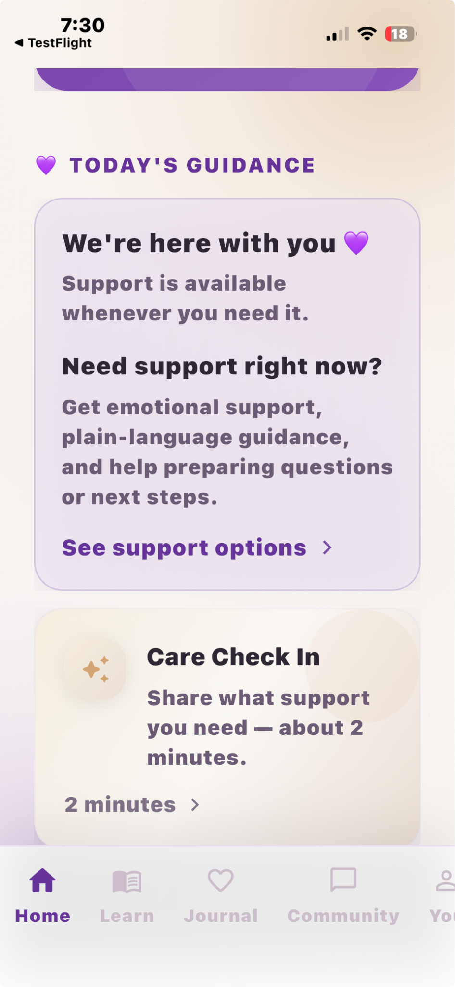

Care Check-In Card
The Care Check-In card currently says: “Share what support you need — about 2 minutes.” This overlaps with Today’s Guidance and makes both cards feel like they do the same thing.
Requested update:
Care Check-In
Tell us what you needed help with and whether you got it.
Start check-in →
3. Trimester / Learning Center Card  The large purple trimester card is visually strong, but it takes up too much space on the home screen.  Requested update:  Please convert this into a shorter learning card.  Week 38 • Third Trimester (or whatever week the mama is)  What to expect this week, what to ask, and when to call your provider.  Open Learning Center → | 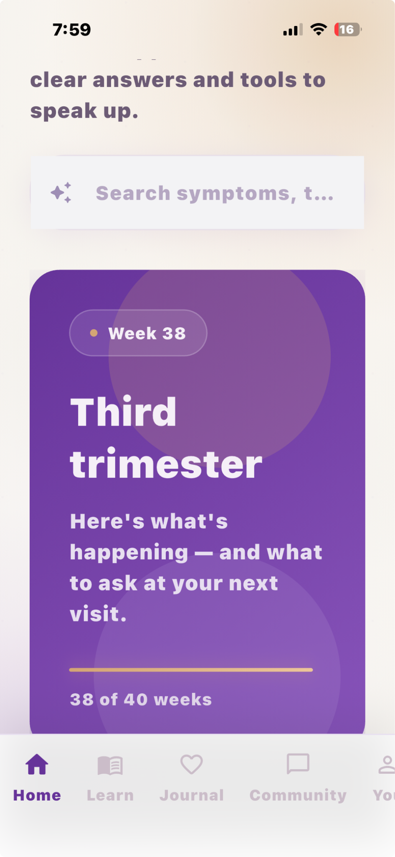
Under “My Visits" it still says loading. | 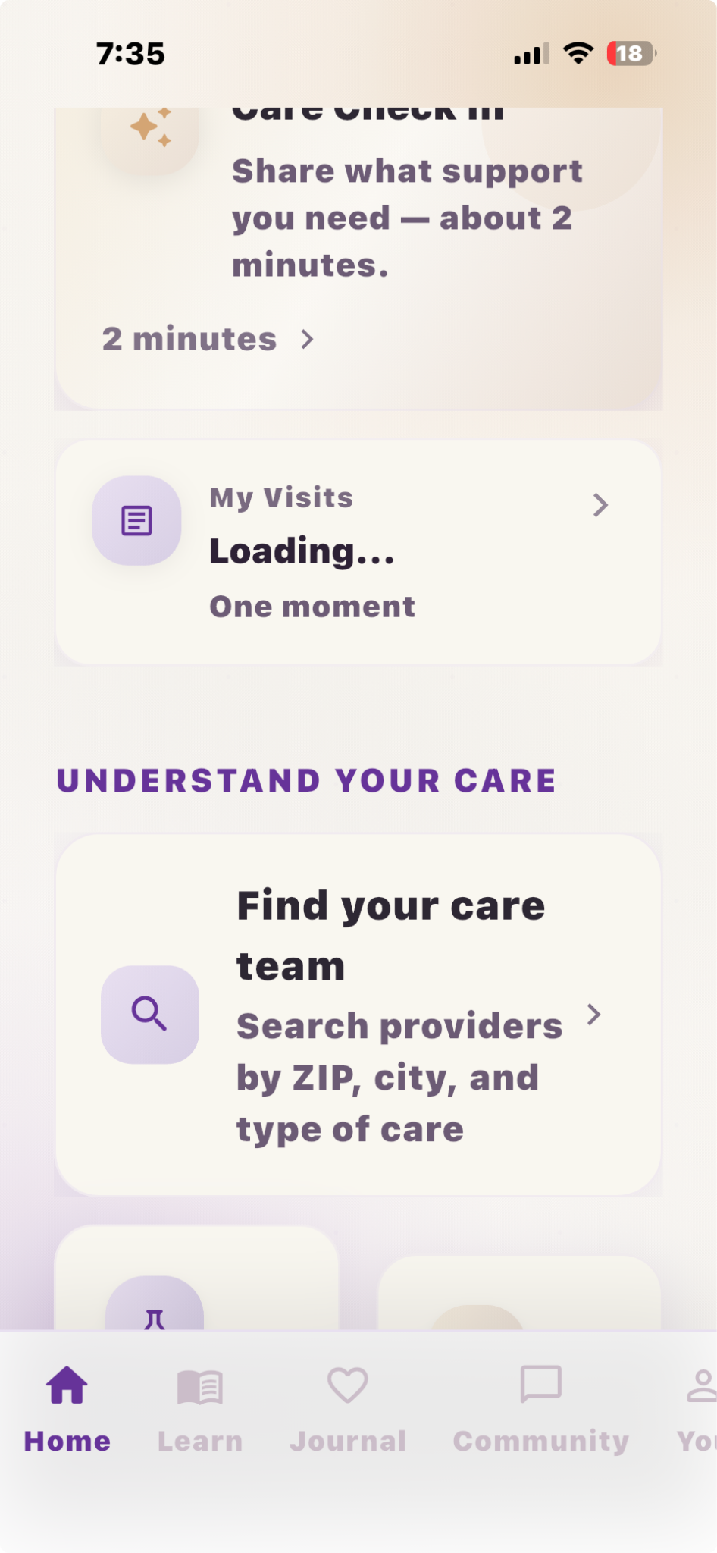
Find your Care Team Requested Update  Please allow provider search to function as a universal search.  The system should return matching results regardless of provider type.  Provider specialty filters can remain available as optional filters but should not be required before searching. | 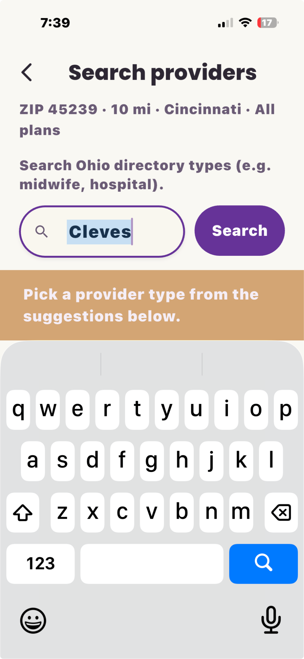
Home Screen Layout Feedback  Revise the home screen layout  - Welcome / Search  - Your Space  - Today's Guidance  - Care Check-In  - Trimester Learning Card  - Community | 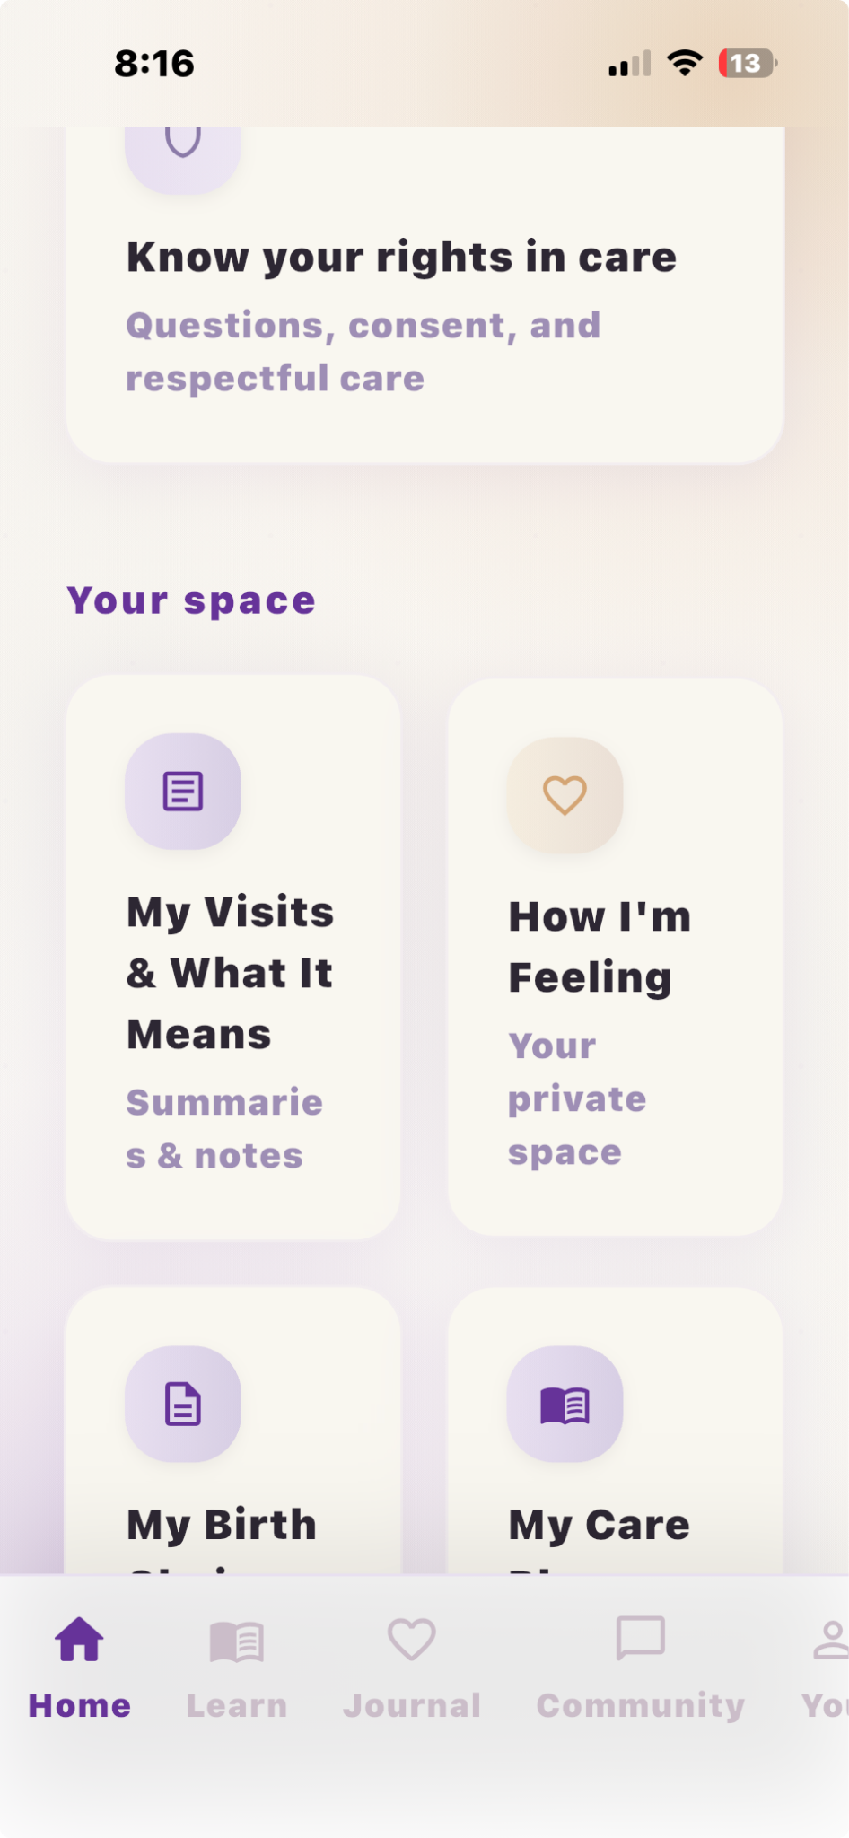
Requested Update  Know your rights  Understand your options and feel confident speaking up. | 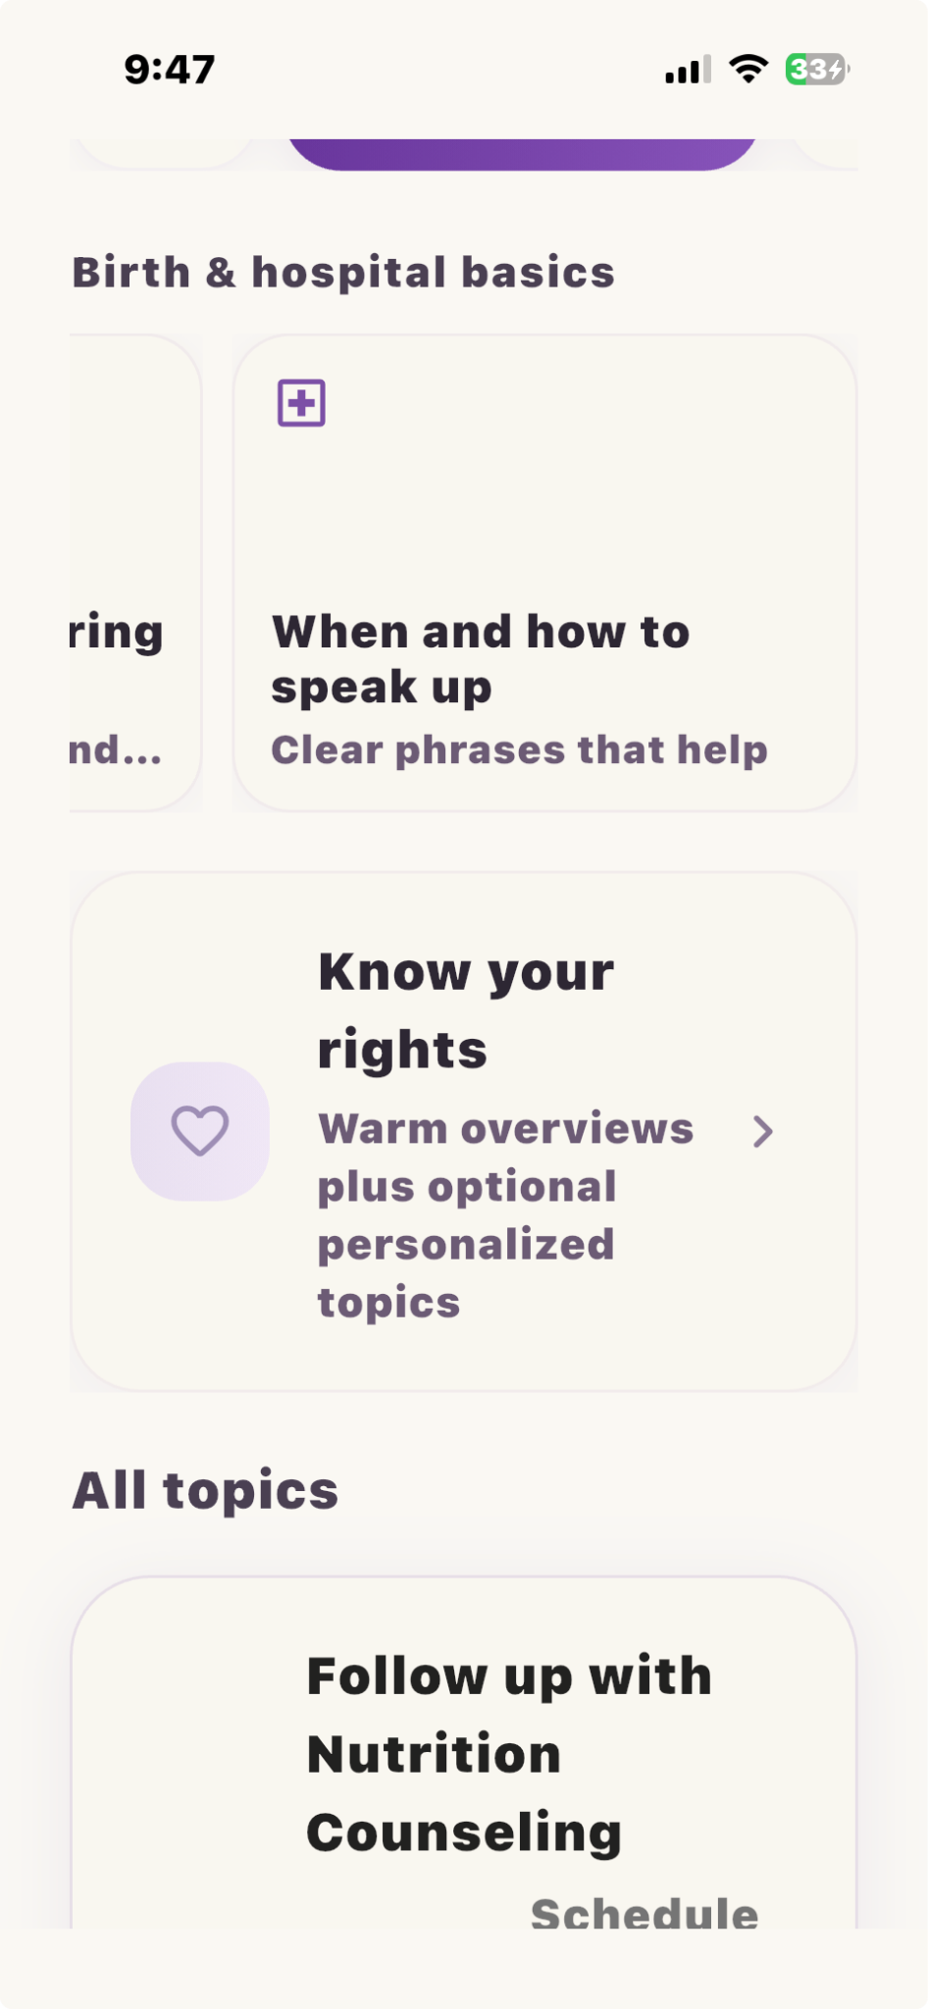
Know your rights  Please remove the "Extra topics below use personalized explanations (AI) — unique to this app" banner from the Know Your Rights page. | 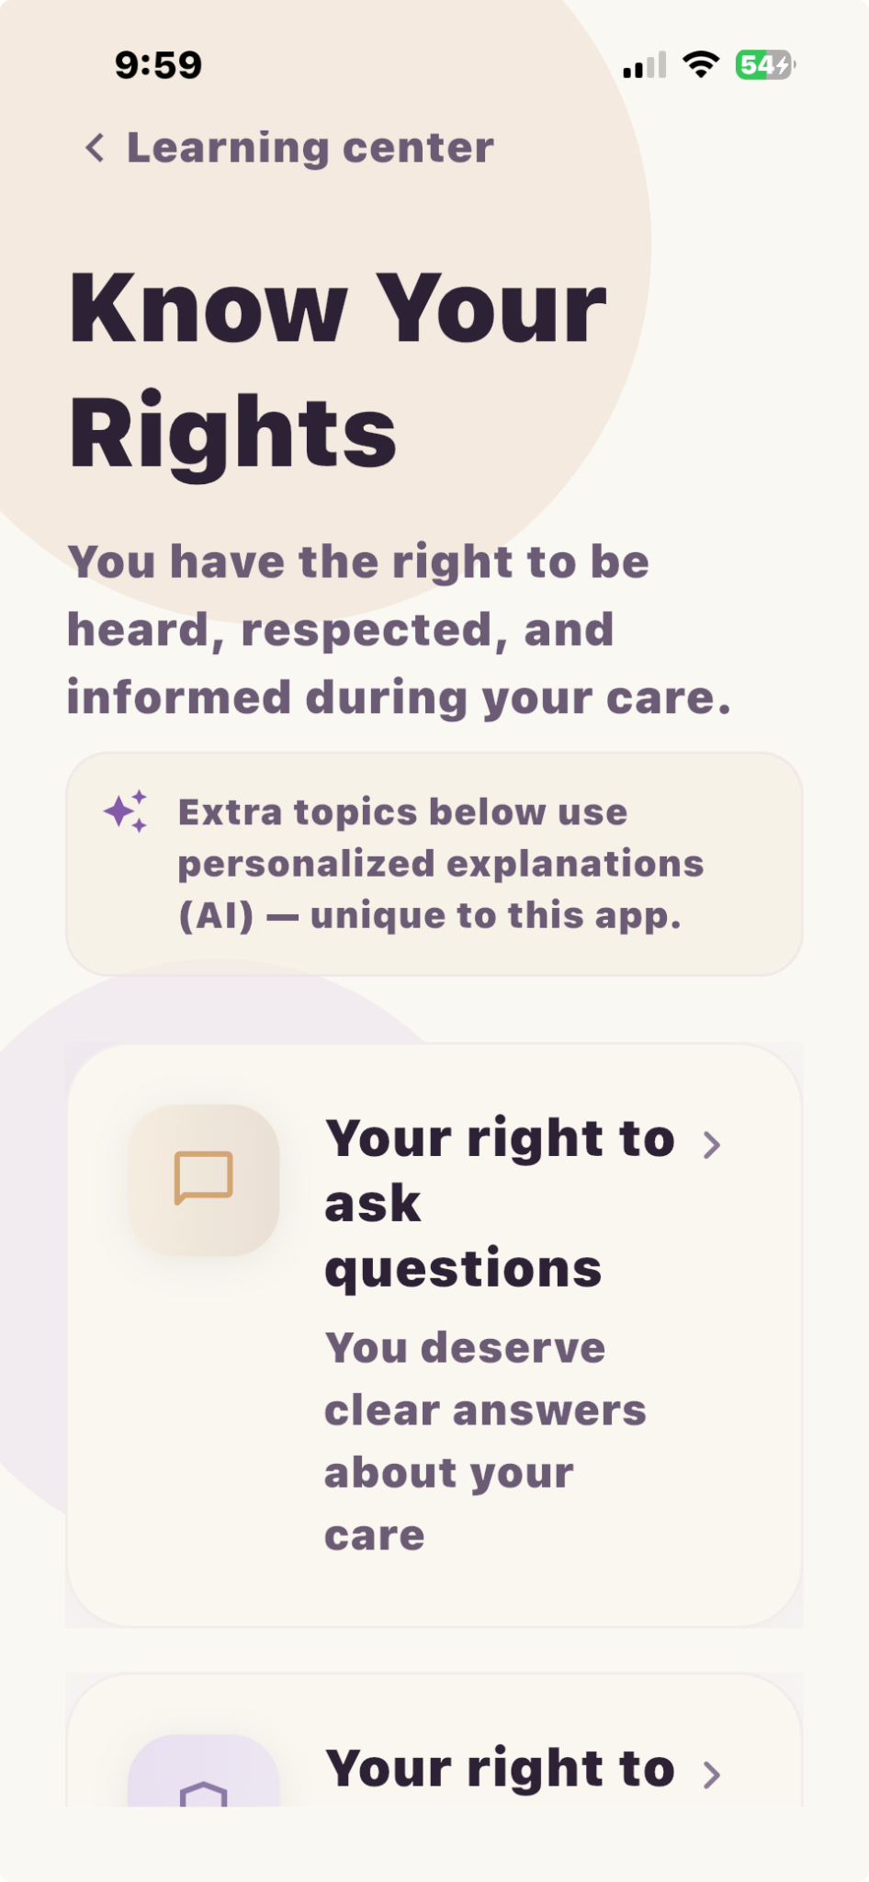
Know your rights  Review copy functionality and consider replacing or supplementing it with Save to Journal using the existing note workflow. | 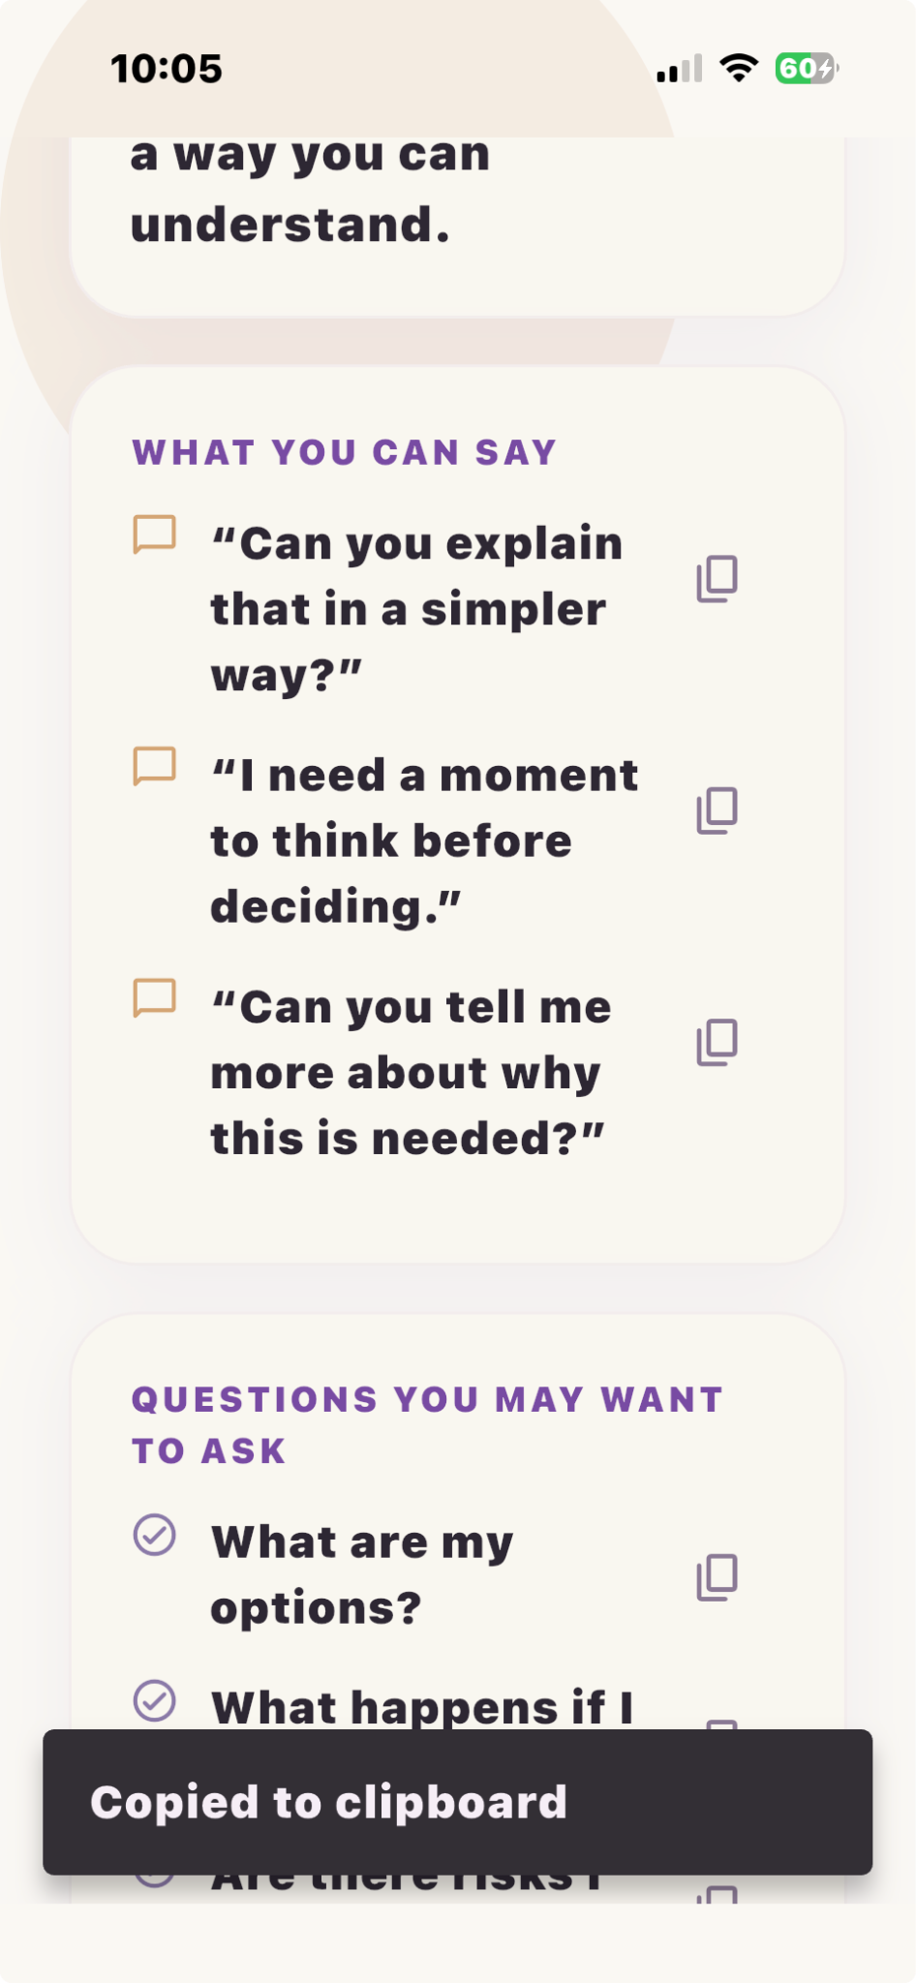
Learning Module Actions (NEW)  Review Add Note / Save / Copy / Share workflow  Consider replacing Copy with Save to Journal functionality  Leverage existing journal tagging system | 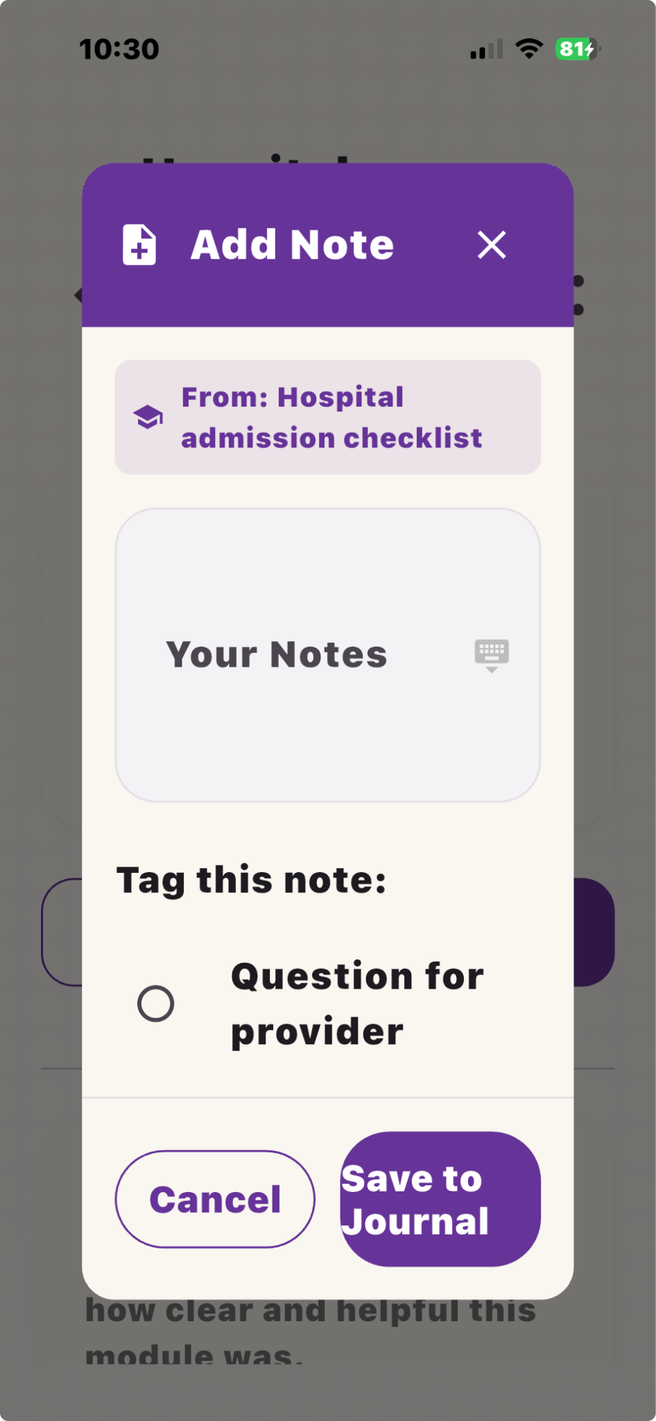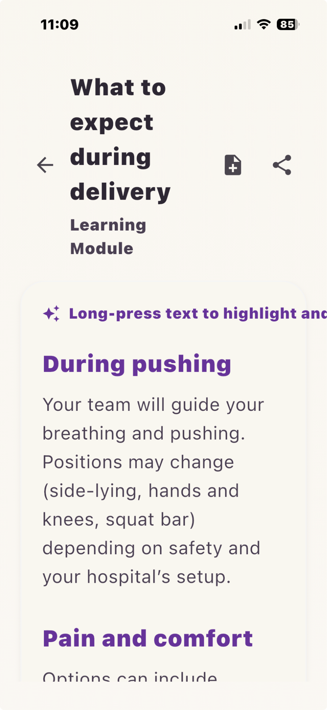
Learning Module Feedback & Care planning tools etc. – Keep It Simple Requested Update  Please place this feedback immediately after module completion rather than low on the page where it may be overlooked.  After learning modules  Did this help?  💜 I understand it better now  🙂 It helped a little  😕 I still have questions  After care planning tools, birth planning, or checklists  How do you feel now?  💪 I feel more prepared  🙂 A little more prepared  😕 Still unsure | 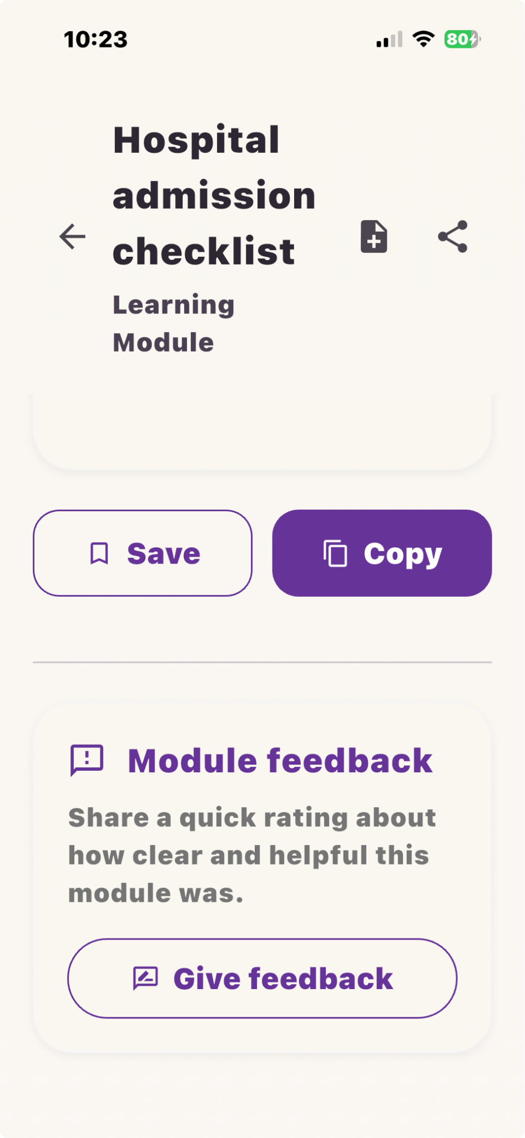
Journal Auto-Categorization Enhancement Requested Update (the plus sign next to hospital admission brings up the tag note feature)  When users save content from educational modules, advocacy prompts, rights content, or provider questions, please automatically categorize the journal entry based on the section where the content originated.  Examples:  Know Your Rights  → Rights & Self-Advocacy  Questions to Ask  → Questions for My Provider  Birth Preferences  → Birth Preferences  Labor & Delivery Education  → Labor & Delivery Questions  Health Made Simple  → Health Information I Want to Remember  Emotional Support  → Emotional Reflection  Goal  Users should not have to manually organize every saved item. The app already knows the content source and can help keep journal entries organized automatically. | 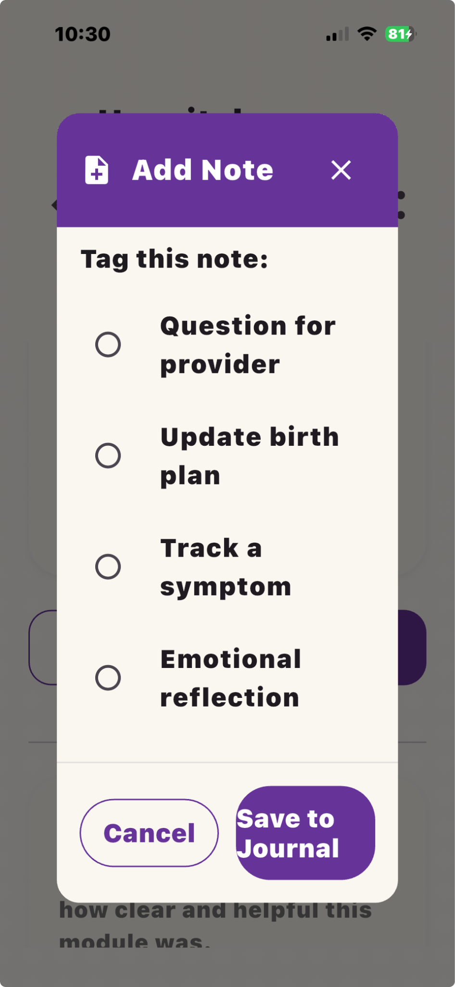
AI Assistant Intro Card – UX Review  Observation  The AI Assistant introduction card remains fixed and visible during the chat experience.  While the information is helpful initially, it occupies a large portion of the screen after the user begins interacting with the assistant.  Requested Update  Please review options to make the AI Assistant introduction less intrusive after the user begins chatting.  (Preferred)  Allow the introductory information card to be dismissed.  Example:  - Add an X icon to close the card  - Once dismissed, the card remains hidden for future sessions unless reset  The primary focus of this screen should be the user's questions and the assistant's responses. | 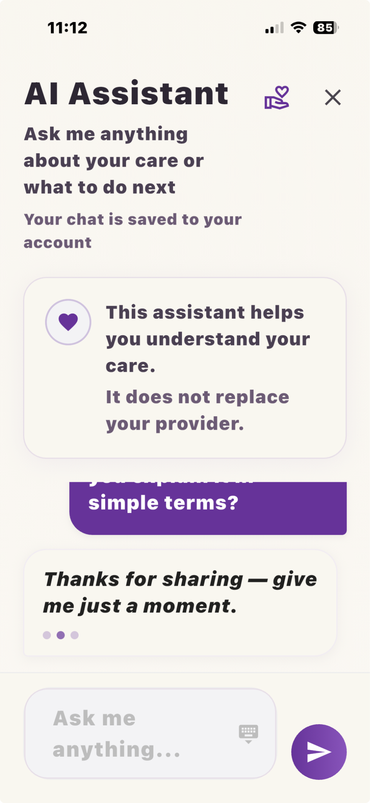
User Testing Findings – Community & Mama Approved™ Alignment  Community + Mama Approved™ Workflow Alignment  Issue Identified  Current testing revealed that the relationship between Community, Provider Reviews, and the Mama Approved™ system is not clear to users.  At present, these features appear as separate experiences:  - Community posts and discussions  - Provider reviews  - Mama Approved™ badges and filters  - Provider search  Users may not understand that community feedback contributes to provider reviews and ultimately informs the Mama Approved™ designation.  Recommended Workflow  Community Experience  ↓  Share Provider Experience  ↓  Provider Review Submission  ↓  Provider Trust Score  ↓  Mama Approved™ Badge  The user journey should clearly communicate that sharing experiences helps other mothers identify providers who are respectful, supportive, and culturally responsive. | 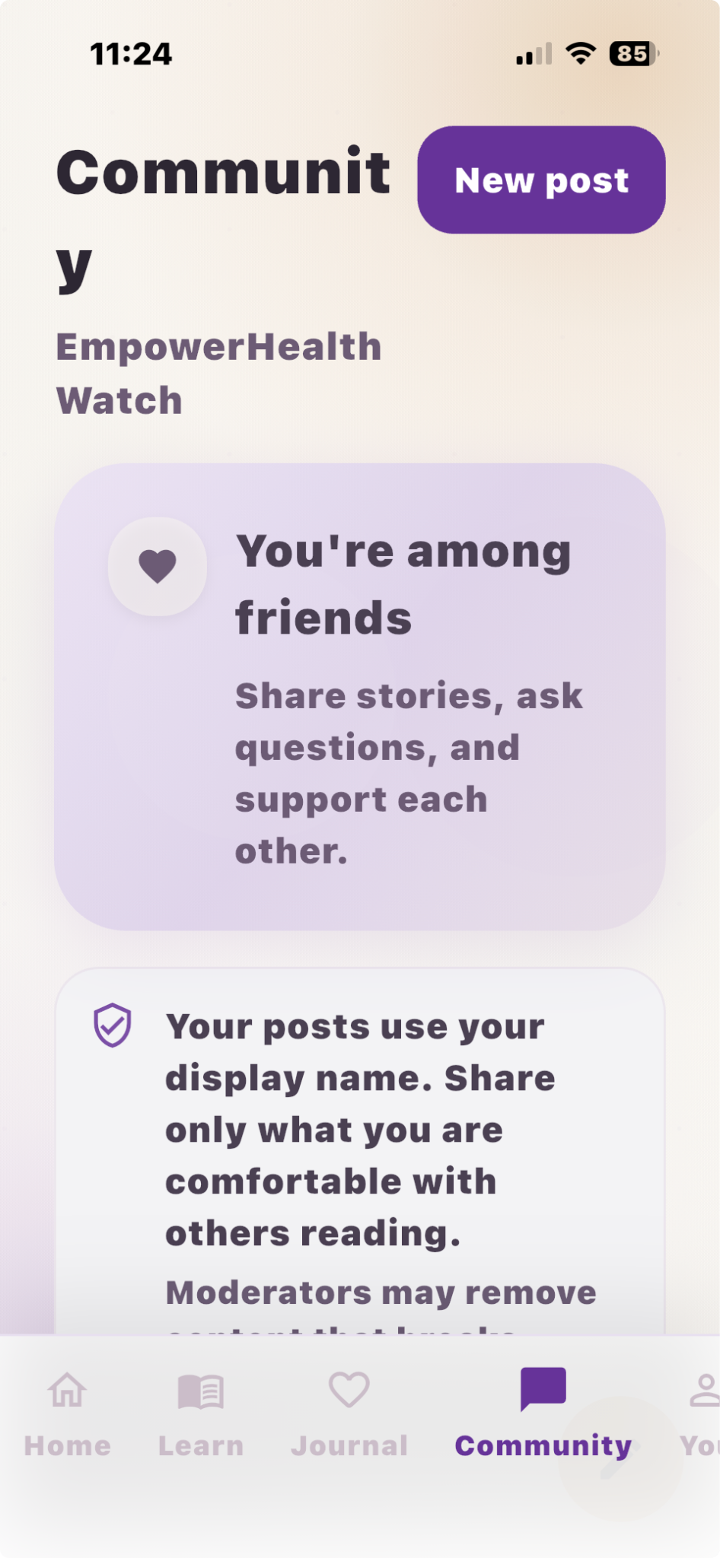
Community Section Revision  Replace:  "Help another mama"  With:  "Help Another Mama Choose Care"  Suggested description:  "Share your experience with a provider, hospital, doula, or birth team. Your feedback helps other mothers find care where they feel heard, respected, and supported."  Suggested CTA:  💜 Share Provider Experience | 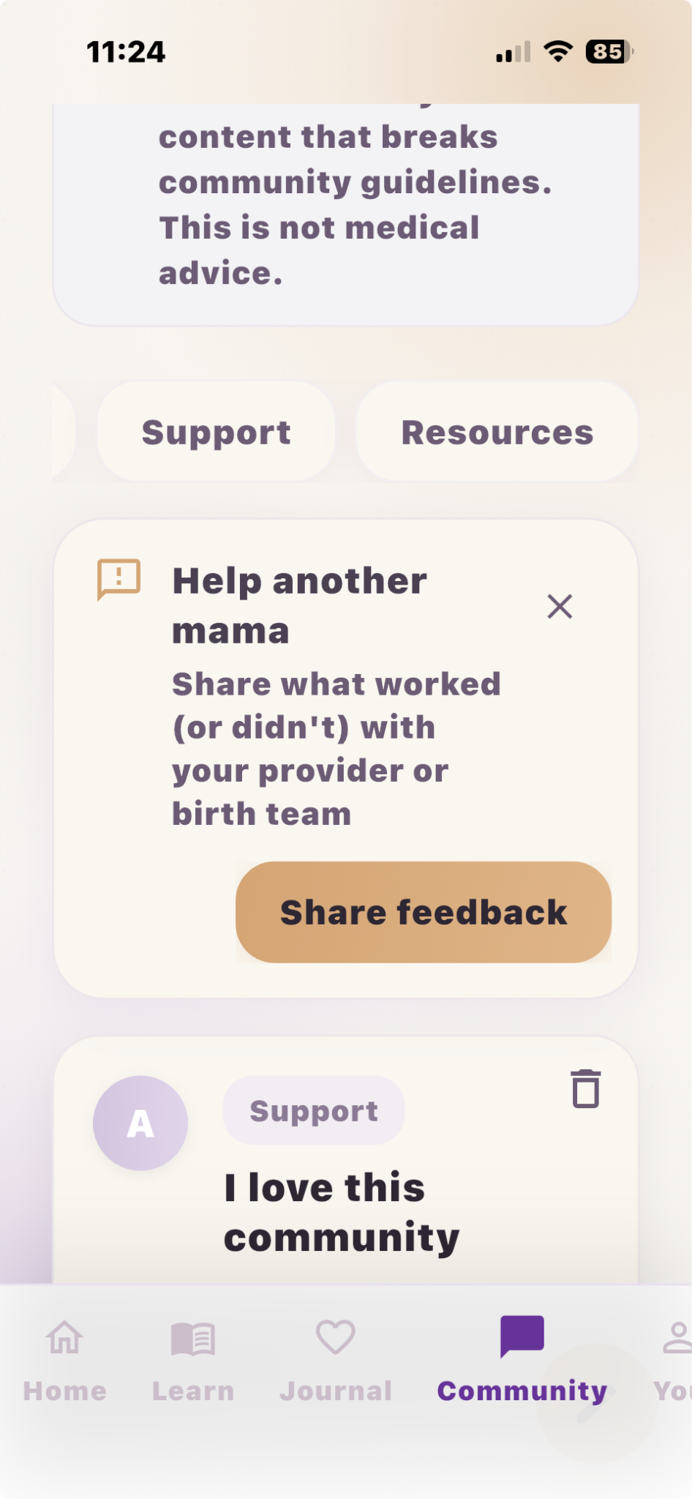
Provider Review Integration  Provider review submissions should be considered the primary source of Mama Approved™ qualification.  Current review questions already support this model:  - I felt heard  - I felt respected  - Things were explained clearly  These responses should contribute to provider trust indicators and Mama Approved™ scoring. | 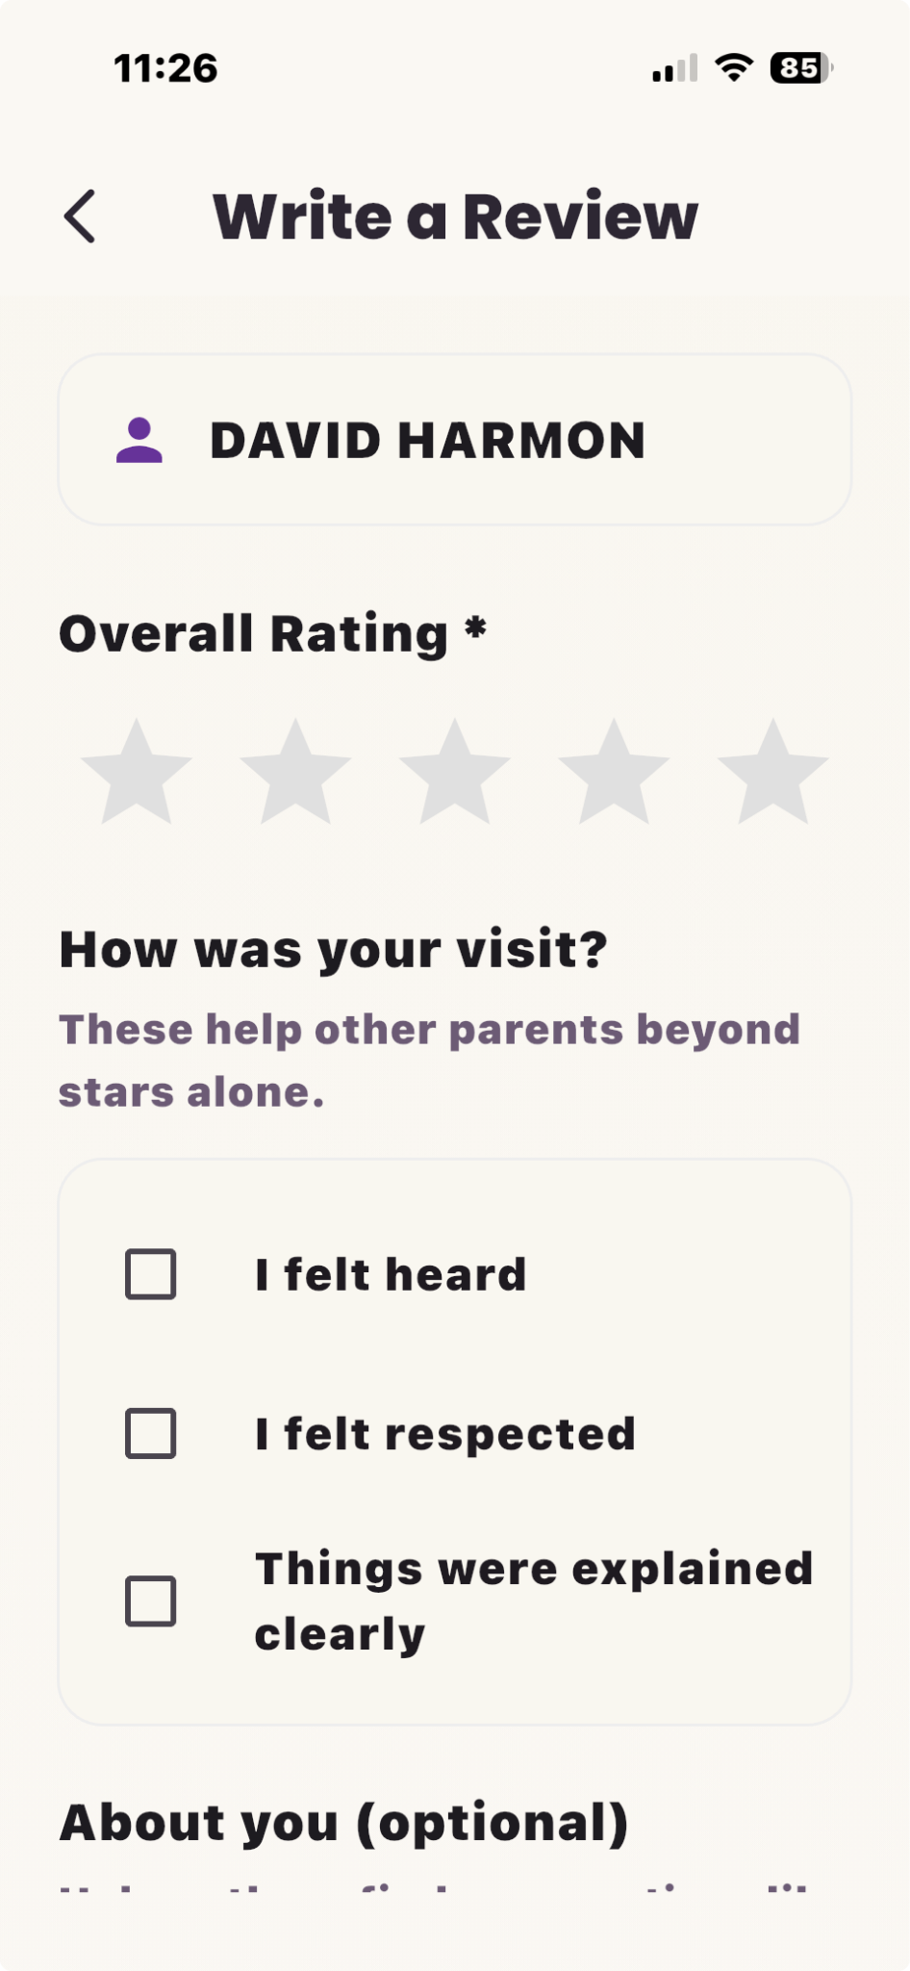
Community Feedback Survey Review  Current community survey items focus on community participation:  - I feel supported by this community  - I feel heard when I share something here  Recommend evaluating whether these questions align with EmpowerHealth Watch's primary mission of:  - Health literacy  - Care navigation  - Patient advocacy  - Support resource access  Alternative survey items may include:  - This app helped me understand my care.  - This app helped me prepare for an appointment.  - I found information that was useful to me.  - I would recommend this app to another mother. | 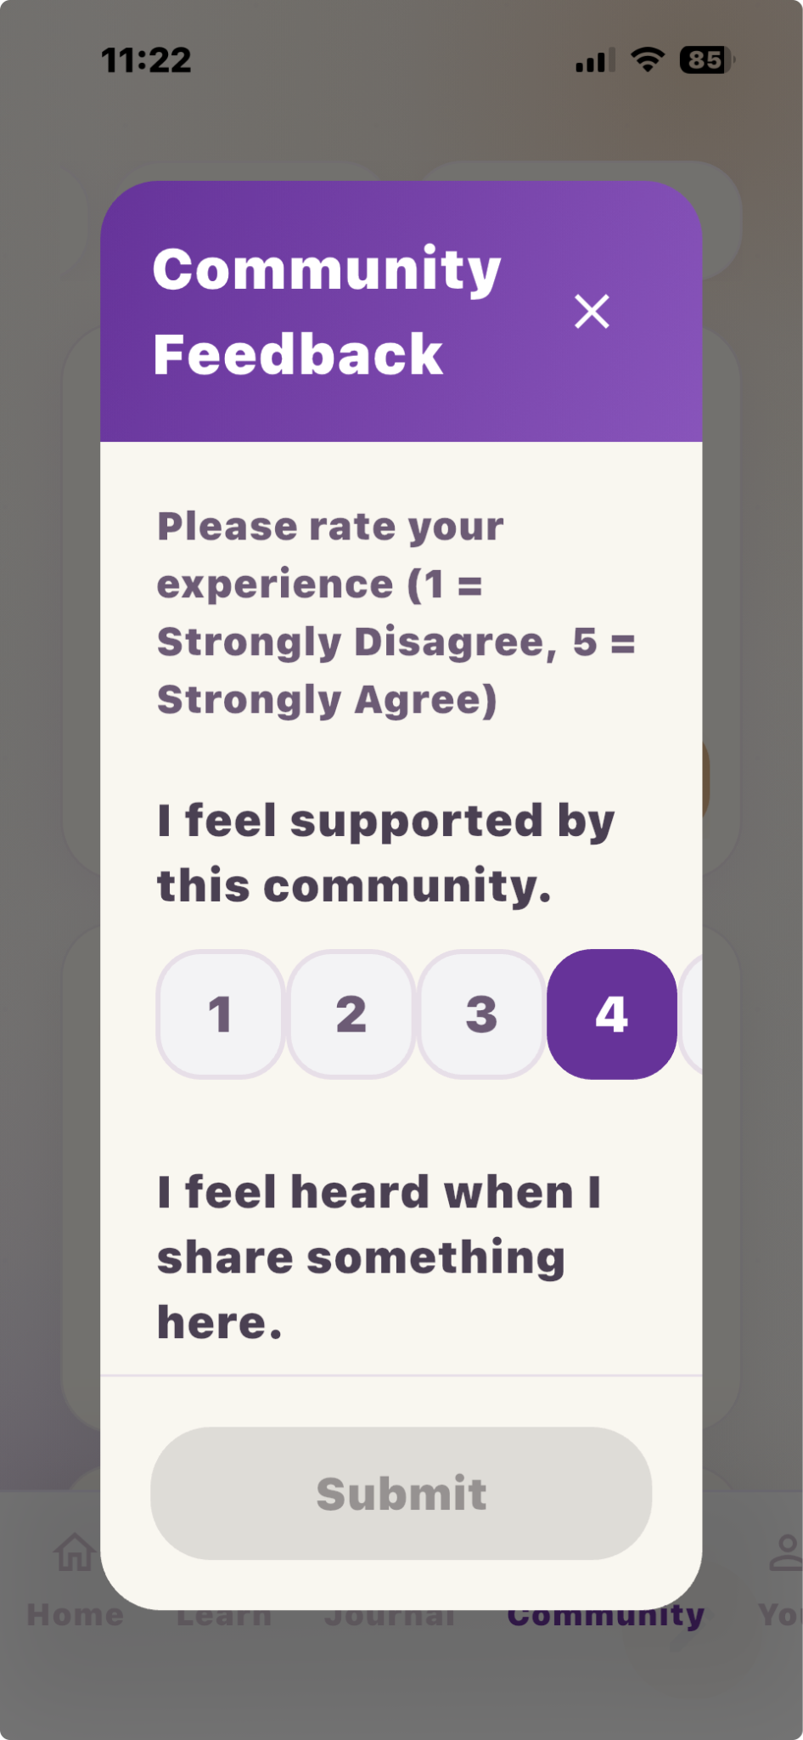

UI Priority
Priority fixes identified during testing:
- Fix provider profile rendering issues affecting visibility of Mama Approved™ badges.
- Create explicit navigation between Community → Reviews → Mama Approved™.
- Reposition Community contributions as provider experience sharing.
- Clarify the purpose and value of Mama Approved™ throughout provider search and provider profiles.
- Ensure Mama Approved™ is presented as a core trust feature rather than an isolated badge.
Pregnancy Details Edit Function  Issue:  During testing I was unable to edit the Pregnancy Details section. The profile displays pregnancy information (week, due date, etc.) but there does not appear to be a functional edit workflow.  Recommendation:  Please verify that users can update:  - Due date  - Current pregnancy status  - Pregnancy stage/week (if recalculated from due date)  - Other pregnancy-related profile information  If editing is already available, please make the entry point more visible. If not, an edit workflow should be added since this information drives personalized content throughout the app. | 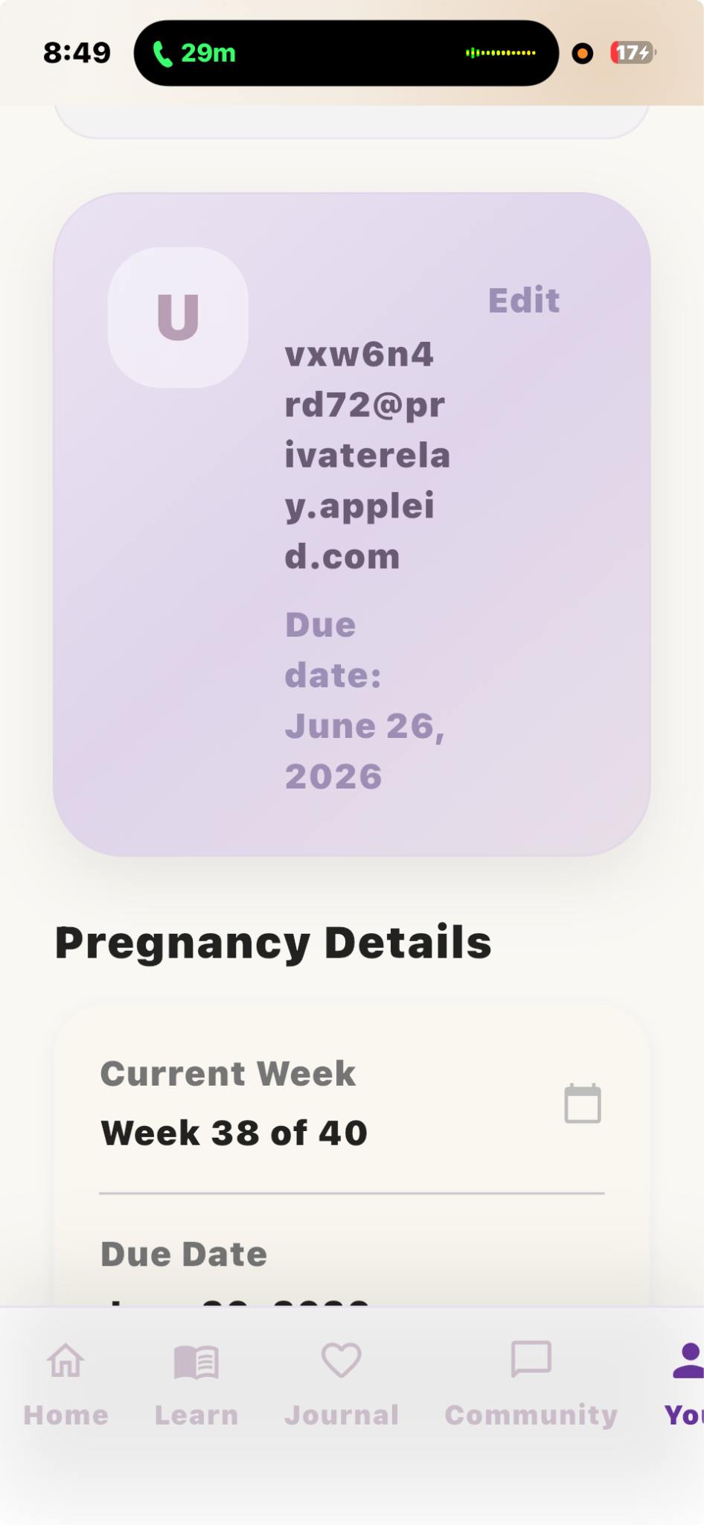

Support Workflow Visibility
Issue:
The Support feature (💜🤲 icon) is difficult to discover because there is no label or explanation describing its purpose.
Recommendation:
Improve discoverability by adding one of the following:
- Label beneath the icon ("Support" or "Get Support")
- First-time user tooltip explaining the feature
- Dedicated support card within the AI Assistant screen
Goal:
Users should immediately understand that this feature provides emotional support resources, self-care tools, and additional support pathways.

V3 EmpowerHealth Watch – Home Screen Revision (Health Literacy Integration)
Purpose
To integrate health literacy and self-advocacy into the home screen experience while maintaining warmth, trust, and emotional support.

The overall goal of app is to help pregnant and postpartum women understand, prepare, and navigate systems that already exist.

Product Support Definition (Core Functionality)
Within the EmpowerHealth Watch app, “help” is defined as providing users with:
Understanding
Clear, plain-language explanations of care, symptoms, and services
Preparation
Tools to help users prepare for visits, ask questions, and advocate for themselves
Navigation
Guidance on next steps and how to move forward in their care
Connection
Direct access to relevant support resources (e.g., WIC, transportation, providers) through links, contact information, or instructions

The app does not directly deliver medical care or services. Instead, it supports users in understanding, preparing for, and navigating existing healthcare and community systems.

1. Welcome Section
Headline: Welcome, Mama 💜
Subtext: You're supported — with clear answers and tools to speak up.
2. Search Bar
Placeholder text options:
- Ask a question about your care
- Search symptoms, tests, or what to ask your doctor
3. Trimester Card
Example:
Week 31 – Third Trimester
You're so strong.
Add line:
Here’s what’s happening — and what to ask at your next visit.

4. Today’s Guidance Section
Section Title: Today’s Guidance
Card Example:
Know what to ask at your next visit
Subtext:
We’ll help you understand your care and speak up with confidence.
Time indicator: 2 minutes
5. NEW Section: Understand Your Care
Add 2–3 quick-access cards:
- What does this test mean?
- Is this normal?
- Know your rights in care
6. Your Space Section (Updated Labels)
- My Visits → My Visits & What It Means
- How I’m Feeling (no change)
- My Birth Preferences → My Birth Choices
- My Next Steps → My Care Plan
7. Assistant Button (Chat)
Microcopy:
Ask me anything about your care or what to do next

Care Needs Check-In (Service Gap Detection + Personalized Support)
Purpose
This section assesses whether users received the care and support they needed and identifies unmet needs in real time.
It supports:
- Personalized user guidance
- Identification of gaps in care delivery (research + improvement)
Screen Title
Did you get the care and support you needed?
Subtext
Let’s check if your care needs were met.
Select anything you needed help with — even if you didn’t receive it.
Response Options (User-Centered Language)
- Doctor or midwife care for me
- Getting ready for labor and birth
- Follow-up for a health concern (e.g., blood pressure, diabetes)
- Emotional or mental health support
- Help with feeding my baby (breastfeeding, pumping, or formula)
- Doctor visits or care for my baby
- Help with benefits or essentials (WIC, Medicaid, diapers, crib, car seat)
- Getting to appointments (rides, transportation, scheduling)
- Something else I need help with
Interaction Behavior
- Multi-select enabled
- User may select none, one, or multiple options
- “Continue” advances to personalized support logic
Personalized Support Logic (Post-Selection)
The app should dynamically generate support options based on user selections.
Display logic should be modular and allow multiple categories to be selected and surfaced simultaneously.
Doctor or midwife care for me
- Find a provider near me
- Prepare questions for my next visit
- Understand my symptoms
Getting ready for labor and birth
- Create or review my birth plan
- What to expect during labor
- Questions to ask my provider
Follow-up for a health concern
- What this condition means (plain language)
- Track symptoms or health data (e.g., blood pressure)
- When to contact a provider
Emotional or mental health support
- Talk to someone now
- What I’m feeling — is this normal?
- Simple ways to get support today
Help with feeding my baby
- Breastfeeding guidance
- Pumping support
- Formula feeding guidance
Doctor visits or care for my baby
- Find a pediatric provider
- What happens at baby visits
- Questions to ask
Help with benefits or essentials
- Find WIC or Medicaid resources
- Access baby essentials (cribs, diapers, car seats)
- Connect with community support services
Getting to appointments
- Find transportation options
- Plan a ride
- What to do if you miss an appointment
Something else I need help with
- Open text input field
- Option to connect to assistant/chat
Optional Reinforcement Message
Display after selection:
We’ll help you understand your options, prepare questions, and find support.

Immediate Support Pathway (Trauma-Informed Universal Support Flow)

Purpose
This pathway provides gentle, trauma-informed support for users who may be emotionally overwhelmed, confused, distressed, anxious, grieving, or unsure what to do next.
The purpose of this pathway is to:
- Provide emotional and informational support without requiring disclosure of sensitive personal experiences
- Help users feel supported without needing to explain what happened
- Offer plain-language guidance and care navigation support
- Connect users to external support resources when appropriate
- Reduce overwhelm and improve clarity during difficult moments
This pathway is intentionally designed to avoid collecting or storing sensitive reproductive-event information.

Placement in App Flow
This support option should be available throughout the app, including:
- Home screen
- Care Needs Check-In
- After-Visit Support areas
- Assistant/chat areas
- Settings/help menu
The feature should always remain optional and user-controlled.

Support Entry Point

Button Options
Recommended:
- I need support right now
- I’m not doing good
- I need help understanding what to do next
Recommended default:
I need support right now

Support Screen

Headline
We’re here with you 💜

Subtext
You do not have to explain everything.
Choose what kind of support would help right now.

Support Options
Allow the user to select one or more options:
- Emotional support
- Help understanding what to do next
- Follow-up care questions
- Help talking to my provider
- Help finding support or resources
- Transportation or appointment help
- Something else I need

Interaction Behavior
- Multi-select enabled
- User may select none, one, or multiple options
- “Continue” advances to personalized support logic
- User should always be allowed to skip this screen
- No sensitive-event disclosure should be required to receive support

Personalized Support Logic
The app should dynamically generate support options based on the user’s selection.
Display logic should be modular and allow multiple categories to be selected and surfaced simultaneously.

If user selects: Emotional support

Display Options
- Emotional support resources
- Stress and coping support
- Ways to care for yourself today
- Breathing or grounding exercises
- Encouragement and reassurance resources
- Connect to external support services

Content Source Requirement
All emotional support content must come from an approved evidence-based resource library.
Approved content sources may include:
- 988 Suicide & Crisis Lifeline
- Postpartum Support International
- SAMHSA
- ACOG
- CDC or other approved public health sources
AI may be used only to:
- simplify approved content into plain language
- organize content based on the user’s selected support need
- suggest gentle next steps
- help the user prepare questions for a provider or support person
AI should not:
- diagnose
- assess risk level
- generate clinical advice
- replace counseling
- create unsupported recommendations
- imply that EmpowerHealth Watch provides crisis monitoring or live support

Suggested User-Facing Language
Here are support options that may help right now. These are educational resources and external support services. EmpowerHealth Watch does not provide counseling or emergency response.

External Support Language
If you need to talk to someone now, you can contact 988 by call, text, or chat. This connects you to the 988 Suicide & Crisis Lifeline, not EmpowerHealth Watch.

Developer Note
Build this section as a curated resource library with AI-assisted plain-language summaries only. AI responses must be grounded in approved source content and should include clear safety language when appropriate.

Suggested Support Message
Your feelings are valid. You do not have to go through this alone.

Support Context
You can talk to a trained counselor right now. This is free and confidential.

UX Requirements
- Clearly indicate this connects to an external, trained support service
- Do not imply in-app counseling or app-based responders
- Provide simple action buttons:
  - Call
  - Text
  - Chat
- Prioritize this option visually

If user selects: Help understanding what to do next

Display
- Plain-language explanations
- Questions users may want to ask their provider
- Guidance on preparing for follow-up care
- Suggestions for organizing next steps

Suggested Support Message
You deserve clear, compassionate information and support.

If user selects: Follow-up care questions

Display
- Questions to ask at a follow-up visit
- When to contact a provider
- Plain-language care guidance
- Ways to prepare for appointments

Suggested Support Message
You deserve care, attention, and clear communication.

If user selects: Help talking to my provider

Display
- Questions to ask your provider
- Words you can use during a visit
- How to ask for clarification
- How to request more support or another opinion

Suggested Support Message
You deserve to be heard and treated with care.

If user selects: Help finding support or resources

Display
- Community support resources
- Mental health resources
- WIC or Medicaid information
- Local support organizations
- Practical support resources

Suggested Support Message
Support may look different for everyone. We’ll help you explore your options.

If user selects: Transportation or appointment help

Display
- Transportation resources
- Appointment planning help
- What to do if an appointment is missed
- Questions to ask when rescheduling

Suggested Support Message
Getting to care can be difficult sometimes. Support is available.

If user selects: Something else I need

Display
- Open text input field
- Option to connect to assistant/chat

Suggested Support Message
Tell us what would feel helpful right now.

Support Content Rules
All support content must follow these rules:

Use
- Gentle, supportive language
- Plain-language explanations
- Calm, reassuring tone
- Clear distinction between emotional support and medical advice
- User-centered language
- “If or when you’re ready” for future-oriented topics

Avoid
- Blaming language
- Alarmist language
- Assumptions about the user’s experience
- Diagnostic language
- Treatment recommendations
- Crisis-monitoring implications
- “Everything happens for a reason”
- “At least…” statements

Home Screen Support Card

Example

Headline
We’re here with you 💜

Subtext
Support is available whenever you need it.

Primary Card
Title: Need support right now?
Subtext: Get emotional support, plain-language guidance, and help preparing questions or next steps.
CTA: See support options

Safety and Resource Guidance
The app should not provide:
- Diagnosis
- Emergency medical assessment
- Treatment recommendations
- Crisis intervention services
- Monitoring of user safety
Where appropriate, the app may include gentle safety guidance:
If you feel unsafe, have severe symptoms, or believe you need urgent medical care, contact your provider or seek emergency care.
For emotional distress:
If you feel like you may hurt yourself or cannot stay safe, call or text 988 for immediate support.

Developer Notes
- This pathway should function without requiring disclosure of sensitive reproductive-event information.
- The app should not store reproductive-event categories or reasons for support requests.
- Support interactions should remain user-controlled and skippable.
- No structured “pregnancy loss” status field should be created.
- No sensitive-event support categories should be included in research exports.
- Content should remain educational, supportive, and navigational — not diagnostic or clinical.
- Resource connections should be informational and external unless formal referral partnerships are developed later.

OTHER AREAS OF UPDATES NEEDED

